The Board of Commissioners for the County of Cabarrus met in regular session in the Commissioners’ Meeting Room at the Cabarrus County Governmental Center in Concord, North Carolina at 6:30 p.m. on Monday, October 16, 2023.

Public access to the meeting could also be obtained through the following means:
live broadcast at 6:30 p.m. on Channel 22 https://www.youtube.com/cabarruscounty
https://www.cabarruscounty.us/cabcotv

Present - Chairman: Stephen M. Morris
Vice Chairman: Lynn W. Shue
Commissioners: Timothy A. Furr
Christopher A. Measmer
Kenneth M. Wortman

Also present were Mike Downs, County Manager; Richard M. Koch, County Attorney; Rodney Harris, Deputy County Manager; Kyle Bilafer, Assistant County Manager; Kelly Sifford, Assistant County Manager; and Lauren Linker, Clerk to the Board.

Chairman Morris called the meeting to order at 6:30 p.m.

Chairman Morris led the Pledge of Allegiance.

A moment of silence was observed.

Chairman Morris recognized Adit Kamdar, Youth Commission, Concord High School, who was in attendance.

(A) APPROVAL OR CORRECTION OF MINUTES

(A-1) Approval or Correction of Meeting Minutes

UPON MOTION of Vice Chairman Shue, seconded by Commissioner Measmer and unanimously carried, the Board approved the minutes of October 2, 2023, as presented.

(B) APPROVAL OF THE AGENDA

UPON MOTION of Commissioner Furr, seconded by Commissioner Wortman and unanimously carried, the Board approved the agenda as presented.

(C) RECOGNITIONS AND PRESENTATIONS

(C-1) Planning Department- Weatherization Day 2023

Chairman Morris recognized Robert Anderson, Community Development Planner, who read the proclamation aloud.

UPON MOTION of Commissioner Measmer, seconded by Vice Chairman Shue and unanimously carried, the Board adopted the proclamation.

Proclamation No. 2023-18

Proclamation of Weatherization Day 2023
Whereas, October is National Energy Awareness Month, and October 30 is designated as National Weatherization Day; and
Whereas, the County of Cabarrus has a long-standing commitment to conserve its resources and to help low-income households through its Weatherization Assistance Program; and
Whereas, the State of North Carolina has administered the Weatherization Assistance Program since its inception in 1976, providing a variety of state and federal resources through numerous community action agencies, housing authorities and departments of local government that serve people in every county in the state; and
Whereas, it is important to recognize the importance of those programs that ensure that all residents, especially those living at or below the federal poverty level, have the opportunity to live in energy efficient, healthy, safe, and comfortable homes as provided for by the Weatherization Assistance Program;
Now, Therefore, Be it Resolved, that the Cabarrus County Board of Commissioners do hereby proclaim October 30, 2023 as:

“Weatherization Day”

in the County of Cabarrus and I urge all citizens to join me in this observance.

Adopted this 16th day of October, 2023.

/s/ Stephen M. Morris______________
Stephen M. Morris
Chairman of Board of Commissioners

(C-2) Veterans Services - Operation Green Light Proclamation

Chairman Morris recognized Tony Miller, Veterans Affairs Director, who read the proclamation aloud.

Commissioner Measmer MOVED to adopt the proclamation. Commissioner Furr seconded the motion.

Following discussion, the MOTION unanimously carried.

Proclamation No. 2023-19

Supporting Operation Green Light for Veterans

WHEREAS, the residents of Cabarrus County have great respect, admiration, and the utmost gratitude for all the men and women who have selflessly served our country and this community in the Armed Forces; and

WHEREAS, the contributions and sacrifices of those who served in the Armed Forces have been vital in maintaining the freedoms and way of life enjoyed by our citizens; and

WHEREAS, Cabarrus County seeks to honor individuals who have made countless sacrifices for freedom by placing themselves in harm’s way for the good of all; and

WHEREAS, veterans continue to serve our community in the American Legion, Veterans of Foreign Wars, religious groups, civil service, and by functioning as County Veterans Service Officers in 29 states to help fellow former service members access more than $52 billion in federal health, disability and compensation benefits each year; and

WHEREAS, Approximately 200,000 service members transition to civilian communities annually; and

WHEREAS, an estimated 20 percent increase of service members will transition to civilian life in the near future; and

WHEREAS, studies indicate that 44-72 percent of service members experience high levels of stress during transition from military to civilian life; and

WHEREAS, active military service members transitioning from military service are at a high risk for suicide during their first year after military service; and

WHEREAS, the National Association of Counties encourages all counties, parishes and boroughs to recognize Operation Green Light for Veterans; and

WHEREAS, the Cabarrus County appreciates the sacrifices of our United States military personnel and believes specific recognition should be granted; therefore be it

PROCLAIMED, with designation Cabarrus County as a Green Light for Veterans County, to salute and honor the service and sacrifices of our men and women in uniform transitioning from active service; therefore, be it further

PROCLAIMED, that in observance of Operation Green Light, Cabarrus County encourages its citizens in patriotic tradition to recognize the importance of honoring all those who made immeasurable sacrifices to preserve freedom by displaying green lights in a window of their place of business or residence from November 6th through the 12th, 2023.

Adopted this 16th day of October, 2023.

/s/ Stephen M. Morris__________________
Stephen M. Morris, Chairman Cabarrus County Board of Commissioners

(C-3) Veterans Services - Veterans Day Proclamation

Chairman Morris recognized Tony Miller, Veterans Affairs Director, who read the proclamation aloud.

UPON MOTION of Vice Chairman Shue, seconded by Commissioner Furr and unanimously carried, the Board adopted the proclamation.

Proclamation No. 2023-20

Proclamation

Veterans Day 2023

WHEREAS, America was founded on the principles of liberty, opportunity and justice for all; and

WHEREAS, America has called on her men and women in uniform to protect our national security, to preserve our rights and freedoms and to keep our democracy safe; and

WHEREAS, through their steadfast defense of America’s ideals, our service members have ensured our country still stands strong, our founding principles still shine, and nations around the world know the blessings of freedom; and

WHEREAS, on Veterans Day November 11, 2023, we recognize the men and women of our Armed Forces who valiantly defended these values throughout our Nation’s History; and

WHEREAS, we also remember and pay tribute to the American armed forces whose courage and sacrifice secures our freedom, keeps the peace and defends our values around the world;

NOW, THEREFORE, the Cabarrus County Board of Commissioners do hereby proclaim November 11, 2023, as National Veterans Day and call upon our citizens to always remember and honor our veterans, and those who continue to serve this country so willingly to preserve the principles of justice, freedom and democracy for all.

Adopted this 16th day of October, 2023.

/s/ Stephen M. Morris__________________
Stephen M. Morris, Chairman
Cabarrus County Board of Commissioners

Mr. Miller invited everyone to the annual Veterans Day celebration to be held at the Boys and Girls Club on Saturday, November 11, 2023 at 11:00 a.m.

Additionally, the Veterans Christmas Breakfast will be Wednesday, December 13, 2023.

(D) INFORMAL COMMENTS

Chairman Morris opened the meeting for Informal Public Comments at 6:42 p.m. He reviewed the Public Participation Policy. Also, each speaker would be limited to three minutes.

Jerry Anderson, resident of 133 Kennedy Avenue in Kannapolis, spoke about the Department of Social Services.

Jeeter Anderson, resident of 133 Kennedy Avenue in Kannapolis, commented on a Department of Social Services matter.

Tristin Deal, resident of Concord, spoke regarding politics.

Mark Ortiz, resident of 155 Wankel Drive, Kannapolis, commented on the housing crisis and the Crisis Assistance Program in Cabarrus County.

Josh Norris, resident of 4353 Shiloh Church Road, Davidson, spoke regarding political matters.

Maegan Mack, resident of Concord, expressed appreciation for the efforts and work done by the Board of Commissioners.

Roland Jordan, resident of 134 Lore Street in Concord, commented on community and personal matters.

Brian Echevarria, resident of 3940 Balmoral Avenue, Harrisburg, spoke regarding the Republican party and it’s platform.

Mark Spitzer, resident 2115 Golfcrest Drive, Kannapolis, provided expressed appreciation to the Board of Commissioners for their leadership in our community.

Commissioner Wortman addressed public comments concerning politics.

There was no one else to address the Board, therefore Chairman Morris closed that portion of the meeting.

(E) CONSENT

(E-1) Active Living and Parks- Matching Incentive Grant Project Approval

The Active Living and Parks Department requested board approval to move forward with four matching incentive grant projects. The approved FY24 Budget has $50,000 for this program.

All applicants presented their respective projects to the Active Living and Parks Commission on Thursday, September 21. The commission recommended that all projects be funded for a total County match of $24,533.

Projects included Concord Rotary Club bicycle repair stations at three Concord Park sites, outdoor classroom at Weddington Hills Elementary School, field maintenance equipment for Hartsell Athletic Association at Rocky River Elementary, and a picnic table outdoor learning space through Cabarrus County 4H.

Supporting documents for priority ranking and the associated budget amendment was provided.

UPON MOTION of Commissioner Furr, seconded by Commissioner Wortman, and unanimously carried, the Board approved recommended grant awards and adopted the associated budget amendment.

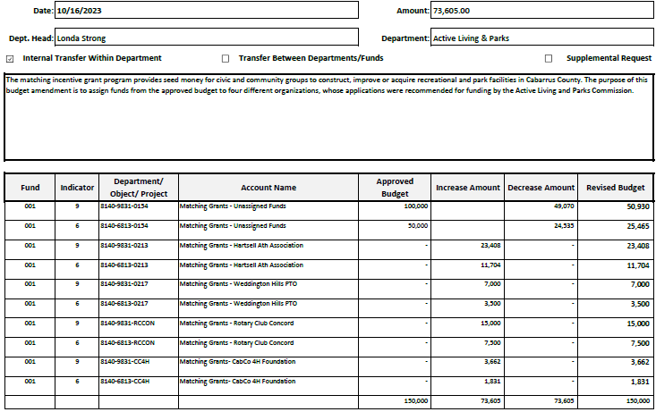

(E-2) Appointments - Early Childhood Task Force Advisory Board

The Early Childhood Task Force Advisory Board (ECTFAB) is comprised of 15 or more members. These members advise the Board of County Commissioners on matters related to the primary development of children birth to five years of age. Members serve a four-year term. Ann Benfield and Spencer Swain have extensive knowledge of early childcare. Their engagement in the ECTFAB will help to provide strong recommendations to the Commissioners and county leadership regarding early childhood development and education. ECTFAB recommended their appointment.

UPON MOTION of Commissioner Furr, seconded by Commissioner Wortman, and unanimously carried, the Board appointed Ann Benfield and Spencer Swain to the Early Childhood Task Force Advisory Board each for a four-year term.

(E-3) Appointments and Removals - Juvenile Crime Prevention Council

The terms for Sergeant Matthew Greer and Sharon Reese expired September 30, 2023. Following confirmation of each members’ desire to renew his/her term for another two years, the Council voted unanimously during its September 20 meeting to recommend both members to be reappointed to another two-year term.

Additionally, Council voted unanimously to accept the resignations of Mark Boles and Heather Jones.

UPON MOTION of Commissioner Furr, seconded by Commissioner Wortman, and unanimously carried, the Board reappointed Sergeant Matthew Greer (Police Chief Designee) and Sharon Reese (DHS Director Designee) to the Juvenile Crime Prevention Council for two-year terms ending September 30, 2025; including an exception to the residency provision of the Appointment Policy for Ms. Reese.

UPON MOTION of Commissioner Furr, seconded by Commissioner Wortman, and unanimously carried, the Board removed Mark Boles (Member of Business Community) and Heather Jones (Public Representative) from the Juvenile Crime Prevention Council and thanked them for their service.

(E-4) DHS - Budget Revision For Adult Protective Services Essential Services Fund

The North Carolina Division of Aging and Adult Services (DAAS) has allocated additional funding for the Adult Protective Services (APS) Essential Services Fund. This funding would allow county departments of social services to provide essential services for adults for whom the need for protective services has been substantiated. These funds would assist adults to age in place, eliminating unnecessary institutionalization and promote opportunities to return to a community-based setting when possible. These essential services would include the provision of medical care for physical and mental health, assistance in personal hygiene, assistance with obtaining appropriate food, clothing, seeking and providing heated and ventilated shelter, providing for protection from health and safety hazards, and protection from abuse, neglect, and exploitation.

Cabarrus County Department of Human Services received $7,559.74 for this fund for FY24; a county match will not be required. A budget amendment will be needed.

UPON MOTION of Commissioner Furr, seconded by Commissioner Wortman, and unanimously carried, the Board approved the budget amendment.

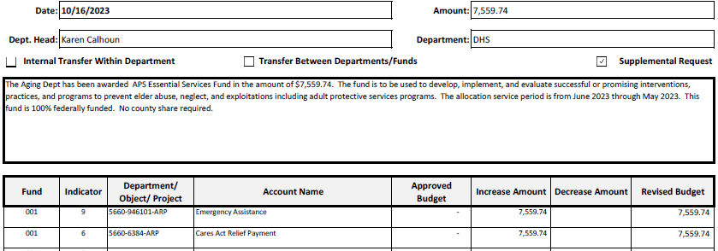

(E-5) DHS - Transportation FY24 Rural Operating Assistance Program (ROAP)

The Rural Operating Assistance Program (ROAP) is a state-funded grant program, which provides funding for trips within Cabarrus County for the elderly and handicapped, employment, and rural general public. It is requested the Board consider acceptance of the grant and approve the required Certified Statement.

UPON MOTION of Commissioner Furr, seconded by Commissioner Wortman, and unanimously carried, the Board accepted the grant and approved the certified statement.

(E-6) Finance - Updated Annual Budget Ordinance

Originally, Cabarrus County along with all counties receiving Opioid settlement funds were instructed that a grant project ordinance could be established and used to track funding and appropriations for the life of the Opioid settlement.

During a recent Local Government Commission Opioid meeting, all the counties were informed that because of the way the Opioid Settlement Memorandum of Understanding (MOU) was written, it was not a grant contract so a grant project ordinance was not a lawful budgeting option. The local government must re-budget the funds in an annual budget ordinance unless the funds are being used for capital purposes.

Since Cabarrus County is in the early stages of determining the best use of these funds, and capital expenditures has not been determined, our option is to add the Opioid Fund to our annual budget ordinance.

UPON MOTION of Commissioner Furr, seconded by Commissioner Wortman, and unanimously carried, the Board approved the updated Budget Ordinance to include the Opioid Fund for Fiscal Year 2024 and approved the corresponding budget amendment.

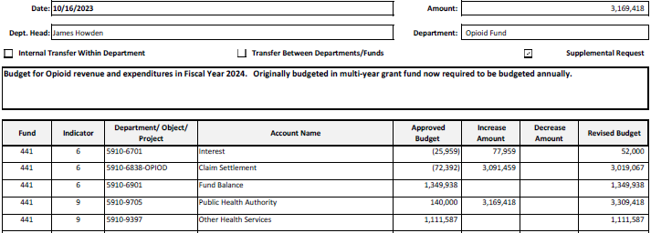

This space has intentionally been left blank.

Ordinance No. 2023-24

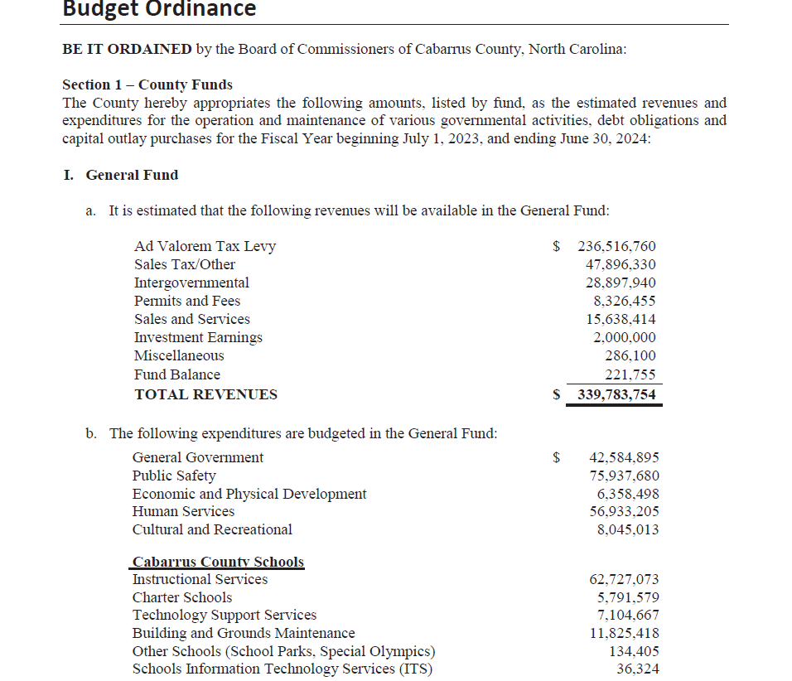
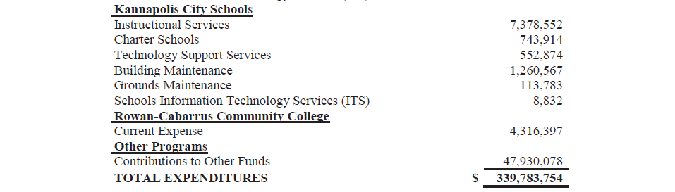
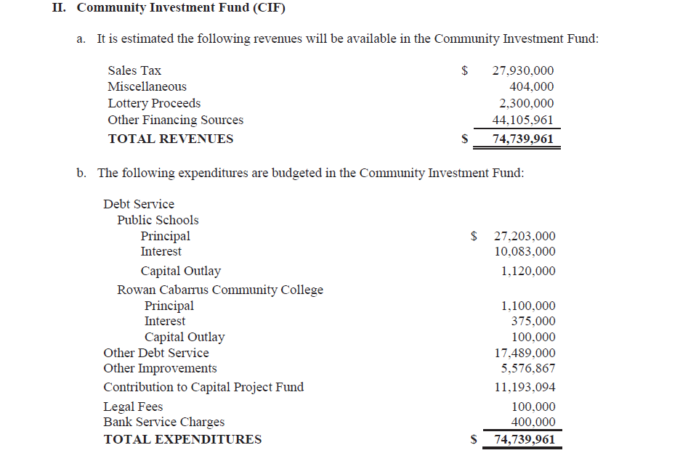
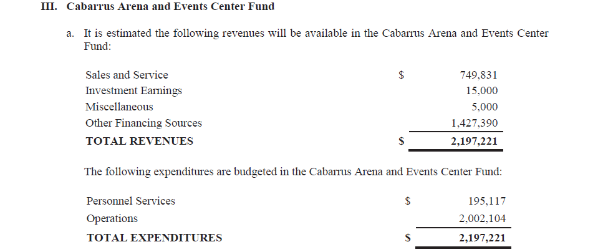
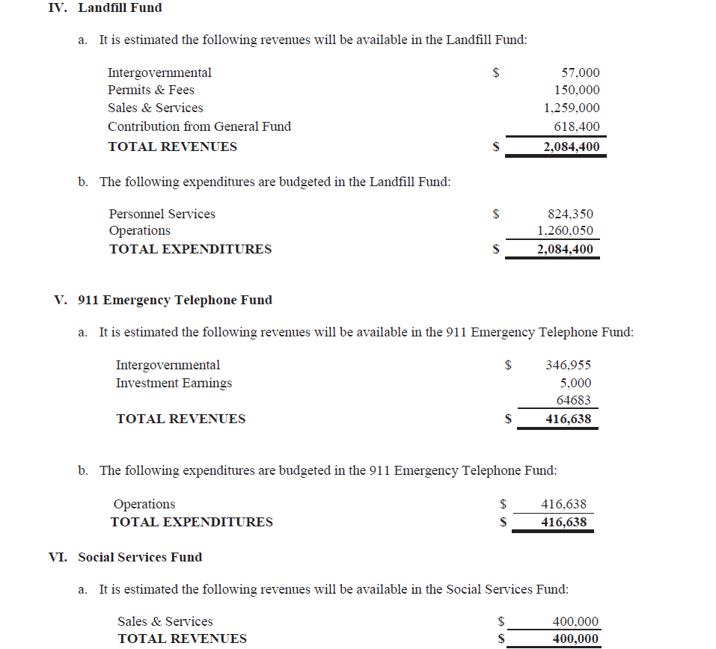
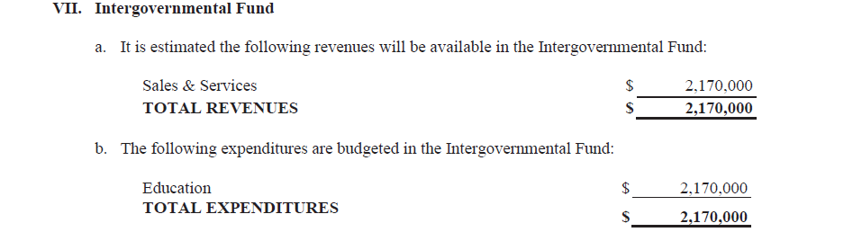

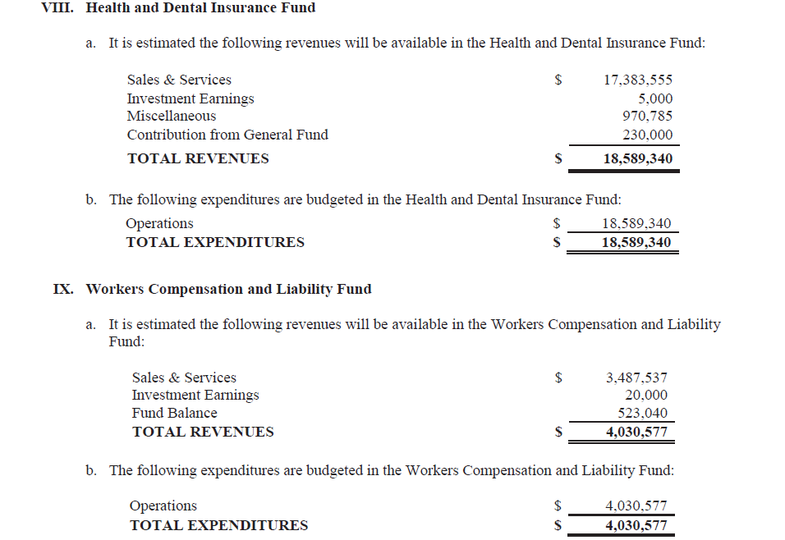
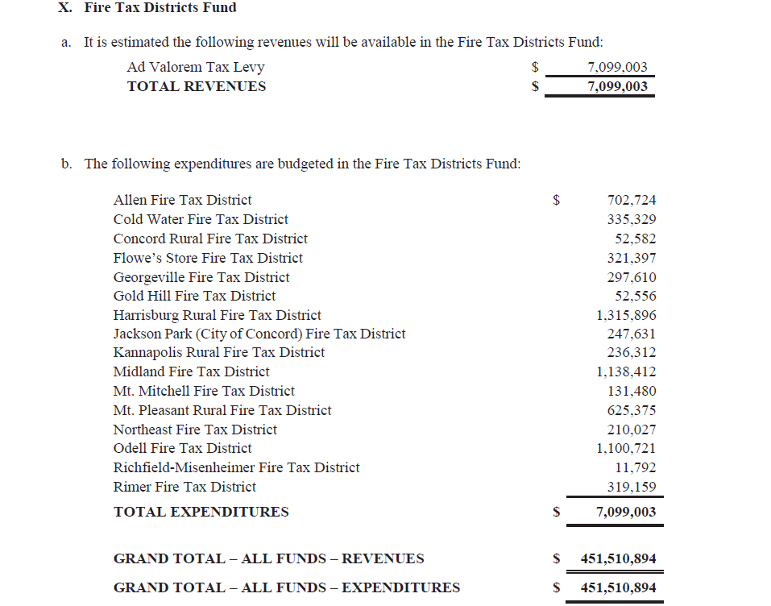
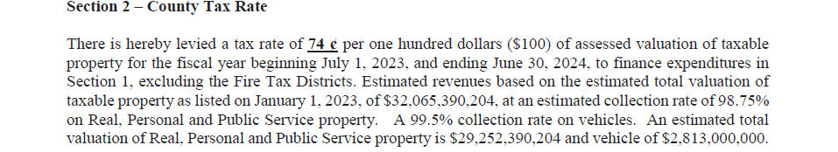

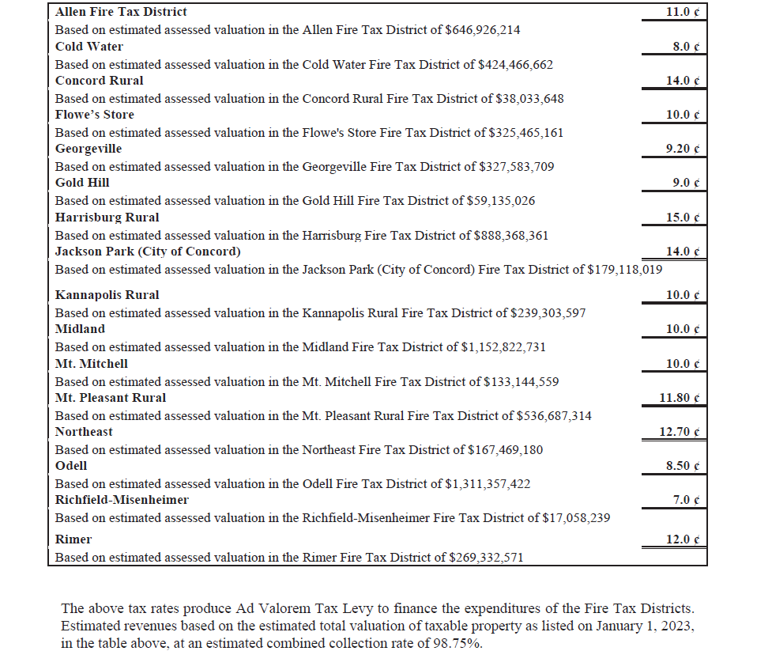

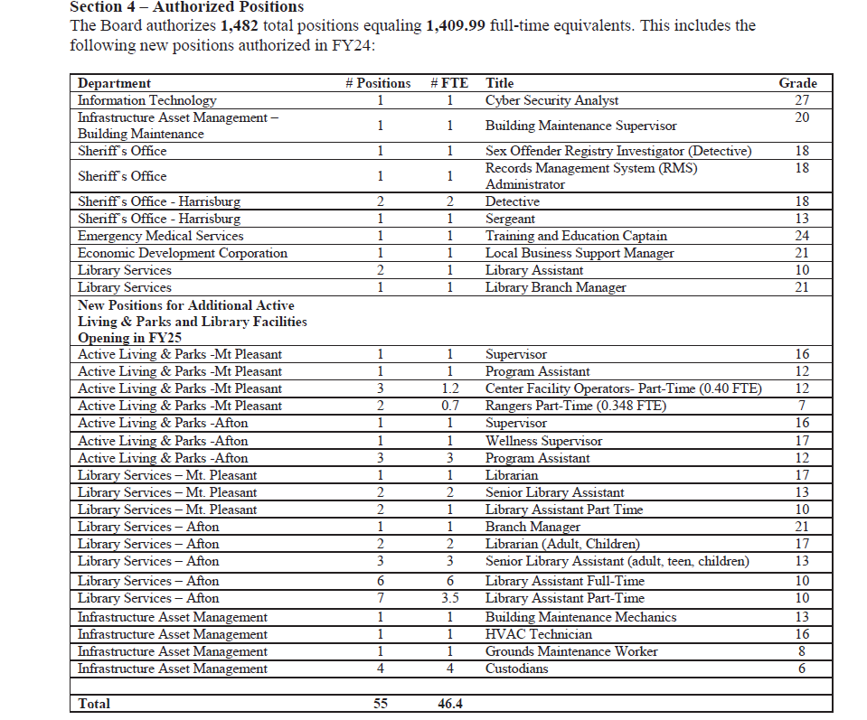
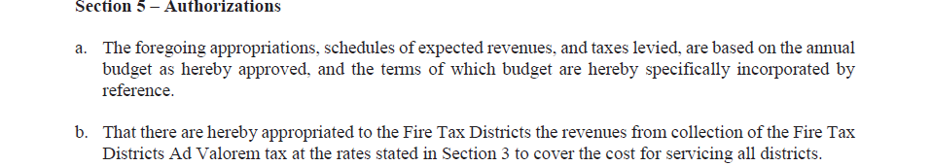
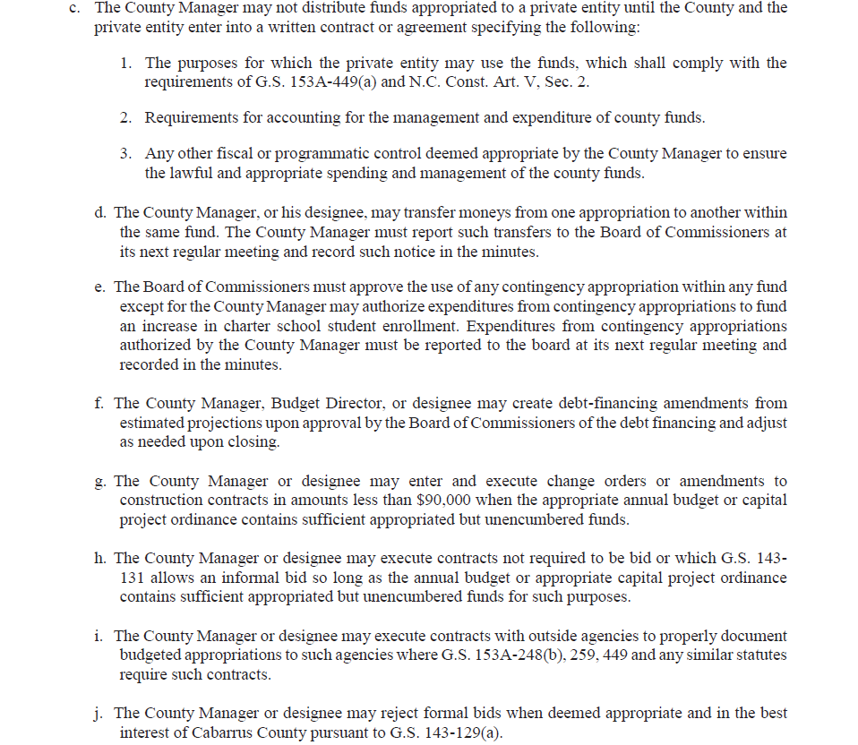

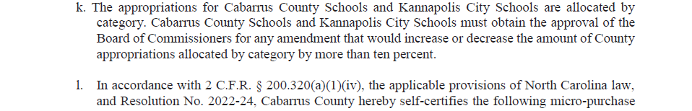
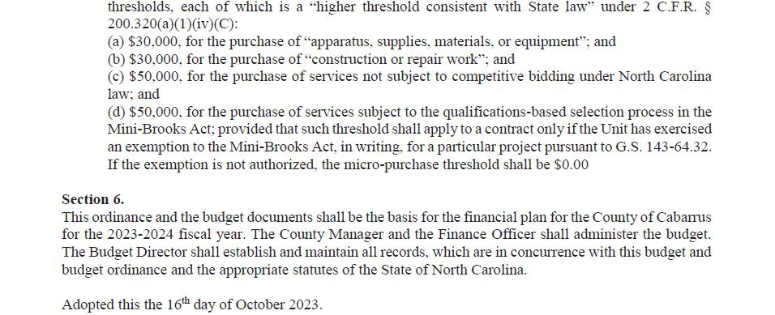

/s/ Stephen M. Morris_____________
Stephen M. Morris, Chairman

/s/ Lauren Linker__________________
Lauren Linker, Clerk to the Board

Ordinance No. 2023-25

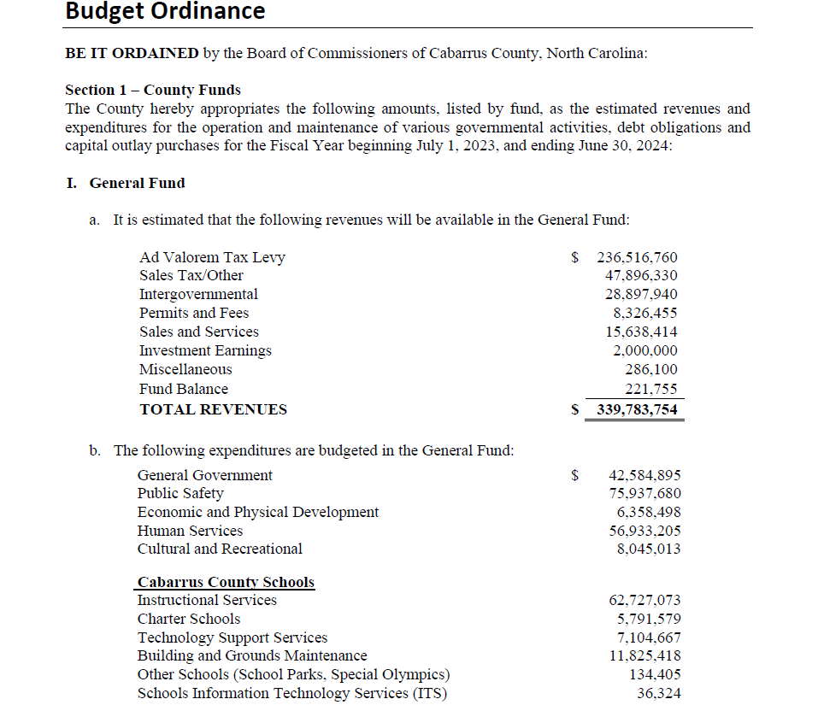
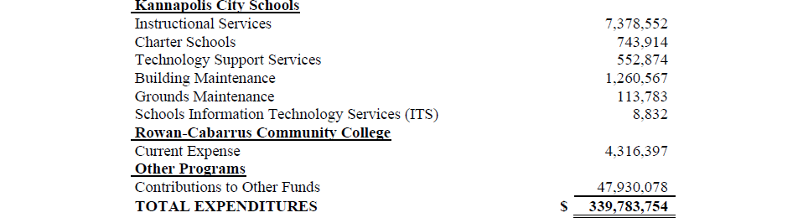
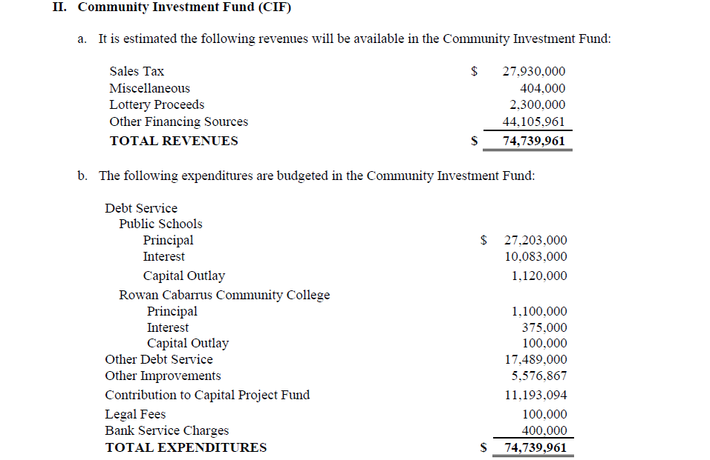
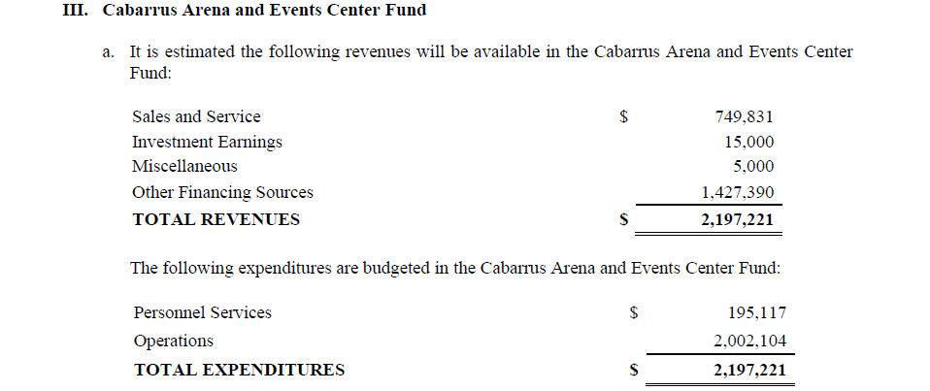
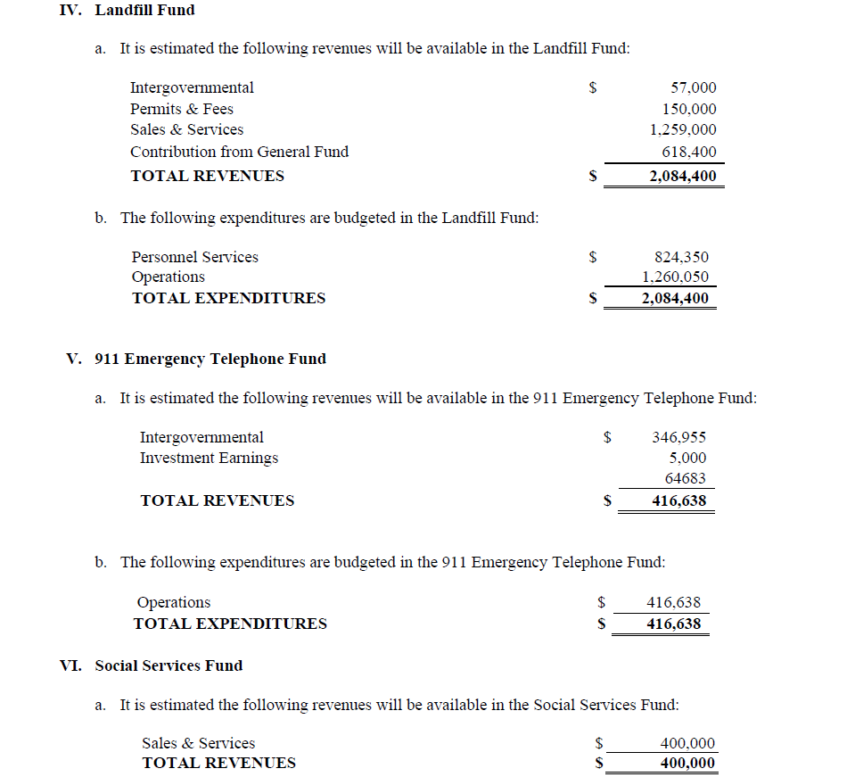
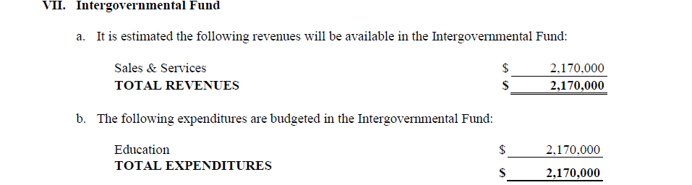

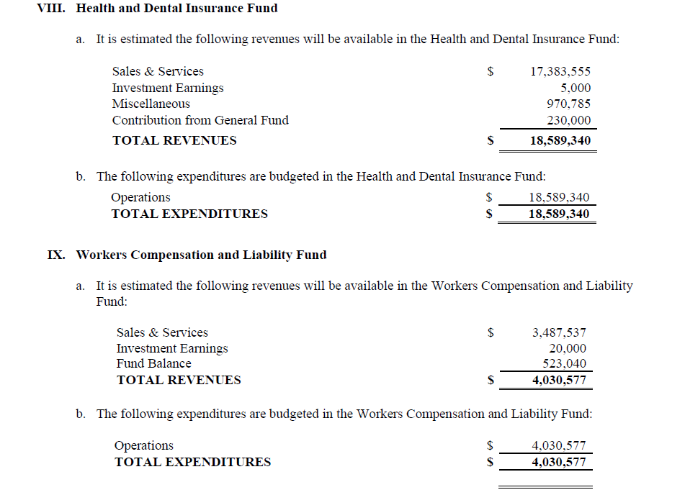
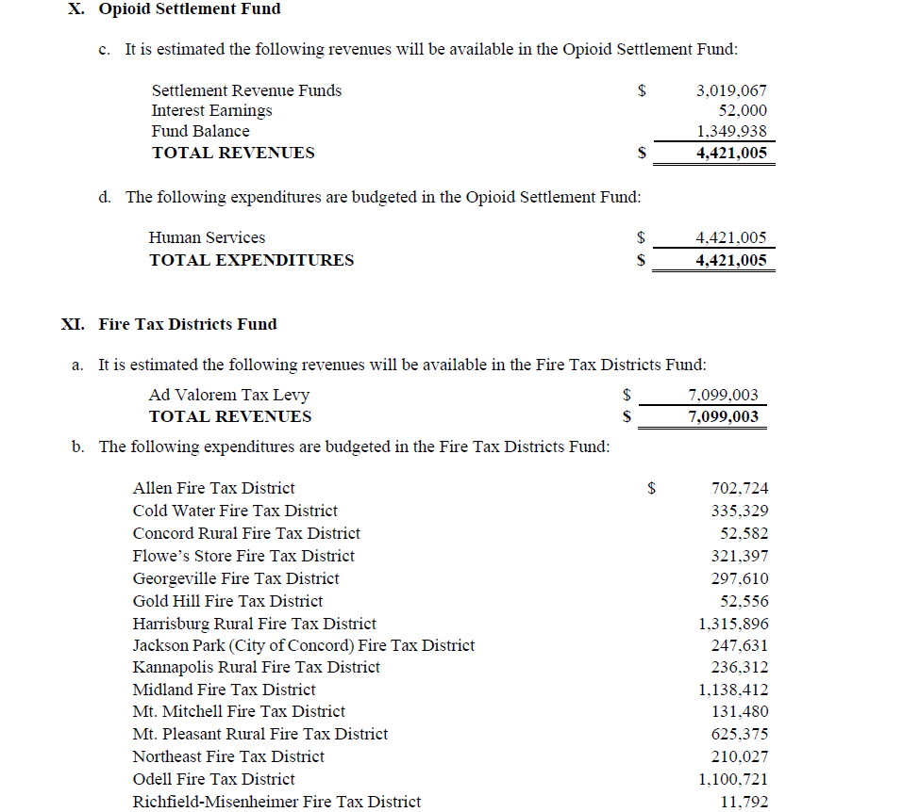
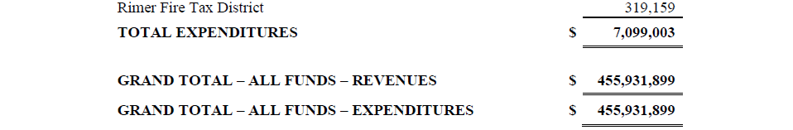

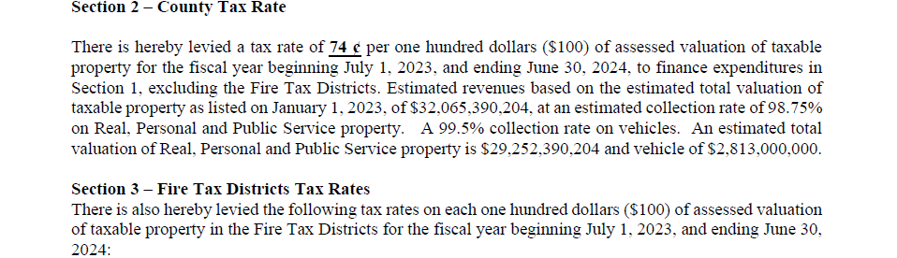
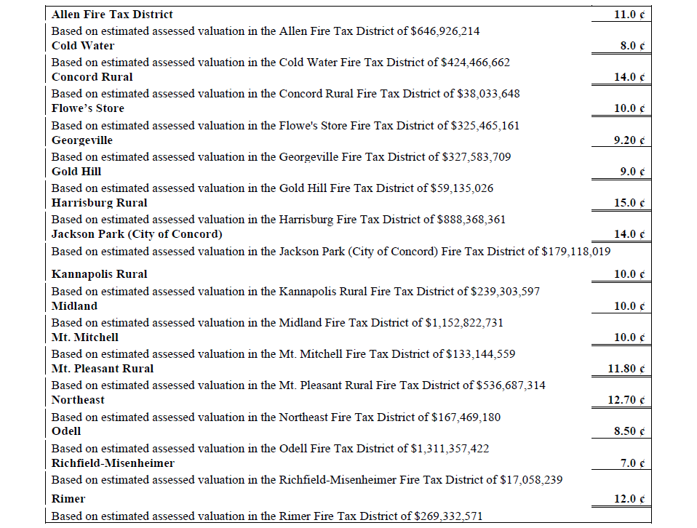

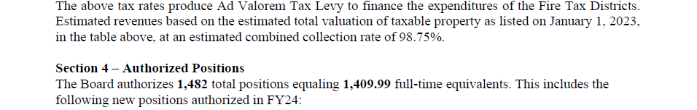

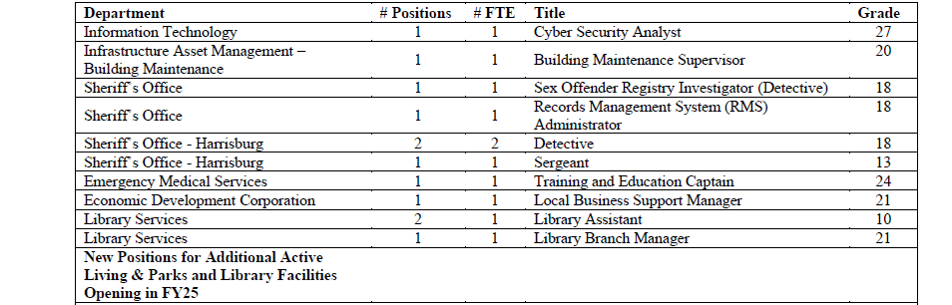
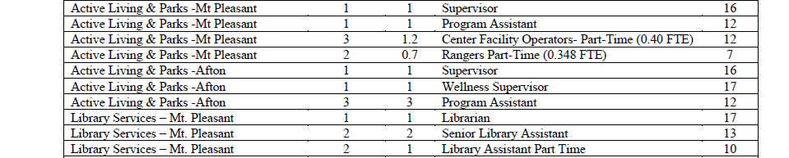

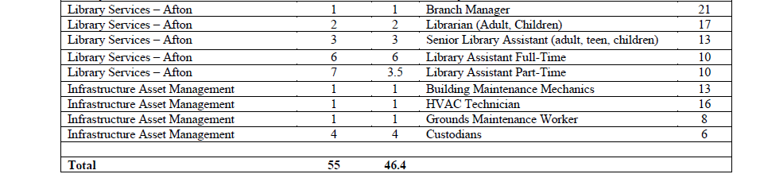

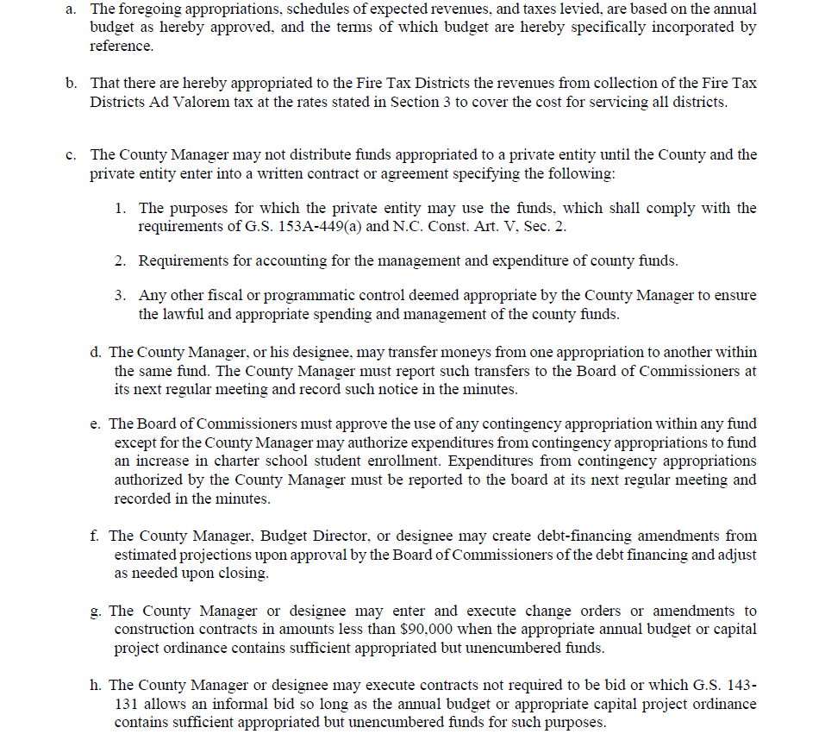

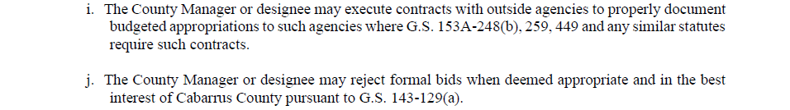

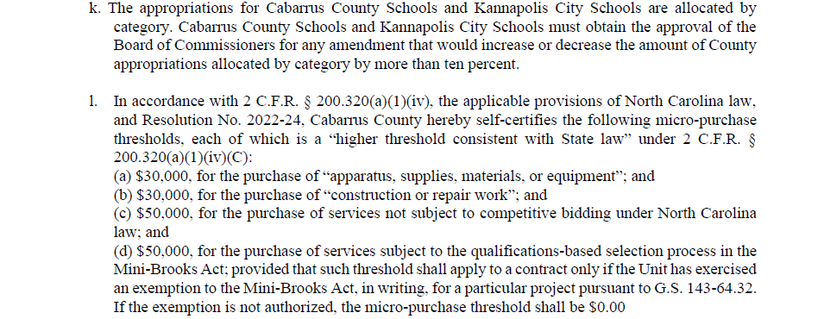

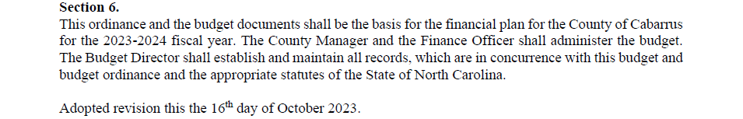

/s/ Stephen M. Morris______________
Stephen M. Morris, Chairman

/s/ Lauren Linker___________________
Lauren Linker, Clerk to the Board

(E-7) Human Resources - Personnel Ordinance Update

Human Resources requested a modification of the Personnel Ordinance to allow paid administrative leave of up to 30 days. This would only be for County Manager or Sheriff approved situations where utilization of the employee’s leave time is not the best resolution for pending personnel investigations. A copy of the personnel ordinance changes/modifications were provided previously.

UPON MOTION of Commissioner Furr, seconded by Commissioner Wortman, and unanimously carried, the Board approved the presented personnel ordinance changes.

(E-8) Sheriff's Office - Budget Amendment for the Purchase of Console Furniture for Backup 911 Center

A request was presented for a budget amendment and approval of the purchase of Backup 911 Center Furniture at the Milestone Building (previously located at the Cabarrus County DHHS location at 1303 S. Canon Blvd.). The back-up center will consist of 8 consoles and must be able to accommodate the number of staffing at the primary 911 center. A backup plan/location for the 911 center is statutorily required by the North Carolina 911 Board. This will mostly be paid by 911 funds; a budget amendment was provided for review. A proposal and quote, which includes shipment and installation at the site, were also provided.

UPON MOTION of Commissioner Furr, seconded by Commissioner Wortman, and unanimously carried, the Board approved the budget amendment.

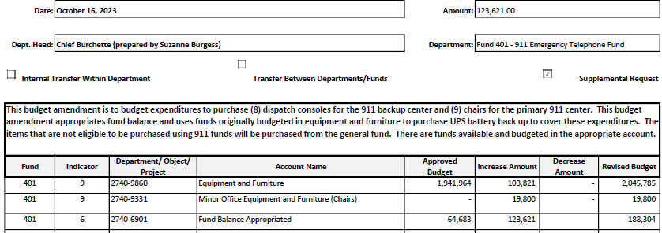

(E-9) Sheriff's Office - Awarding of Service Weapon to Deputy Thomas Hooks

Deputy Thomas Hooks will retire from the Cabarrus County Sheriff's Office on November 1, 2023 after thirty years of service. Pursuant to N.C. General Statute 20-187.2, it is requested that Deputy Hooks' service weapon (Sig Sauer P320C, Serial Number 58C352273) be designated surplus property and awarded to Deputy Hooks for a price of $1.00 upon his retirement.

UPON MOTION of Commissioner Furr, seconded by Commissioner Wortman, and unanimously carried, the Board declared Sig Sauer P320, SN 58C352273, surplus property and authorized disposition in accordance with the County’s policy.

(E-10) Tax Administration - Refund and Release Reports – September 2023

The Release Report contains taxpayers’ names, bill numbers, valuations, tax amounts, along with the justifications for releasing the valuation/tax amounts for outstanding levies in accordance with N.C.G.S. 105-381. The Refund Report is a summary sheet which lists data from each refund request form, along with the justification for the refunds to the taxpayers in accordance with N.C.G.S. 105-381.
Note: Due to the transition of motor vehicles onto the new North Carolina Vehicle Tax System (NCVTS), motor vehicle-related refunds and releases will begin to be displayed on the new report generated by NCVTS.

UPON MOTION of Commissioner Furr, seconded by Commissioner Wortman, and unanimously carried, the Board approved the September 2023 Refund and Release Reports as submitted, including the NCVTS Refund Report, and granted authority to the Tax Collector to process the refunds and releases.

(E-11) Behavioral Health – Amended Resolution to Direct the Expenditure of Opioid Settlement Funds

The Cabarrus County Board of Commissioners adopted a Resolution to Direct the Expenditure of Opioid Settlement Funds on January 17, 2023. The adopted resolution listed and authorized one strategy, Recovery Support Services (Strategy 3). Staff has identified and confirmed an additional strategy, Naloxone Distribution (Strategy 7), as an expenditure of Opioid Settlement Funds for the harm reduction wellness program. Amending the resolution will ensure the resolution aligns with expenditures for the program.

UPON MOTION of Commissioner Furr, seconded by Commissioner Wortman, and unanimously carried, the Board adopted the amended resolution to direct the expenditure of opioid settlement funds.

Resolution No. 2023-30

AN AMENDED RESOLUTION BY THE COUNTY OF CABARRUS
TO DIRECT THE EXPENDITURE OF OPIOID SETTLEMENT FUNDS

WHEREAS Cabarrus County has joined national settlement agreements with companies engaged in the manufacturing, distribution, and dispensing of opioids, including settlements with drug distributors Cardinal, McKesson, and AmerisourceBergen, and the drug maker Johnson & Johnson and its subsidiary Janssen Pharmaceuticals;

WHEREAS the allocation, use, and reporting of funds stemming from these national settlement agreements and certain bankruptcy resolutions (“Opioid Settlement Funds”) are governed by the Memorandum of Agreement Between the State of North Carolina and Local Governments on Proceeds Relating to the Settlement of Opioid Litigation (“MOA”);

WHEREAS Cabarrus County has received Opioid Settlement Funds pursuant to these national settlement agreements and deposited the Opioid Settlement Funds in a separate special revenue fund as required by section D of the MOA;

WHEREAS section E.6 of the MOA states:

E.6. Process for drawing from special revenue funds.

- Budget item or resolution required. Opioid Settlement Funds can be used for a purpose when the Governing Body includes in its budget or passes a separate resolution authorizing the expenditure of a stated amount of Opioid Settlement Funds for that purpose or those purposes during a specified period of time.

- Budget item or resolution details. The budget or resolution should (i) indicate that it is an authorization for expenditure of opioid settlement funds; (ii) state the specific strategy or strategies the county or municipality intends to fund pursuant to Option A or Option B, using the item letter and/or number in Exhibit A or Exhibit B to identify each funded strategy, and (iii) state the amount dedicated to each strategy for a stated period of time.

NOW, THEREFORE BE IT RESOLVED, in alignment with the NC MOA, Cabarrus County authorizes the expenditure of opioid settlement funds as follows:

- First strategy authorized

  - Name of strategies:
Recovery Support Services (Strategy 3); Naloxone Distribution (Strategy 7)
  - Strategy is in:
Exhibit A

  - Item letter and/or number:
Exhibit A #3 and #7

  - Amounted authorized:
$210,000

  - Term:
November 1, 2022 through October 31, 2025

  - Description of the program, project, or activity:

In the context of a harm reduction wellness program, funding will be used to support peer support, education, and naloxone distribution. Services include the following:
- Linkages to care based on participant needs
- Peer support/case management services
- Outreach to engage participants
- Harm reduction education, naloxone distribution, and providing safer use supplies to participants

Peers have received extensive training in Wellness Recovery Action Planning (WRAP), motivational interviewing, Naloxone use, and case management. They offer referrals to MAT, lead sober living/transitional housing meetings, provide social work services, and inform and guide future programming from the lens of lived experience. They also provide employment-related support, like job search guidance, interview coaching, and resume review. Peers are based in our health department, but also provide services out in the community in sites like the jail, treatment centers, and transitional housing/sober living. By the end of the project, CHA will have served at least 1,120 unique individuals through Peer-led overdose prevention education.

  - Provider:
Cabarrus Health Alliance (CHA)

The total dollar amount of Opioid Settlement Funds appropriated across the above named and authorized strategies is $210,000.

In compliance with the guidance outlined in the MOA, this Resolution hereby supersedes and replaces the previous resolution dated January 17, 2023

Adopted this the 16th day of October 2023.

/s/ Stephen M. Morris____________
Stephen M. Morris, Chairman
County Board of Commissioners
ATTEST:

/s/ Lauren Linker____________
Clerk to the Board

(E-12) Behavioral Health - NC Opioid Settlement: Collaborative Strategic Planning
Cabarrus County is slated to receive at least $21,886,625 over 18 years as part of the NC Opioid Settlement Agreements. The Collaborative Strategic Planning process is a requirement to access a longer, more comprehensive list of funded strategies under Option B to address opioid misuse, addiction, overdose, or related issues. To ensure Cabarrus can leverage all possible strategies, a portion of opioid settlement funds will be used to hire a consulting firm to lead the process. An RFP was released in August 2023. Eight firms submitted proposals. The Cabarrus Opioid Review Team led by the Behavioral Health Director, and including members from Emergency Management Services, Cabarrus Health Alliance, Cabarrus Human Services, and Cabarrus Sheriff’s Office, reviewed the proposals to select a firm. A scoring matrix was used to assess each submission. Health Management Associates was the firm identified through the competitive process.
Collaborative Strategic Planning was described by the State as the following: Collaborative strategic planning allows all people in a community to provide input into developing a plan and facilitates planning that is well-matched to the needs of their community. People who use drugs, and those with a history of drug use, are one of the groups that that should have a real voice in the creation of programs and plans designed to serve them. This strategy allows programs to understand the needs of their community, maximize limited resources, coordinate with key partners and ensure that services are not duplicated.
The initial phase of planning will lead to a funding plan covering the next 3 - 5 years. Required activities include the following:
A. Engage diverse stakeholders
B. Designate facilitator.
UPON MOTION of Commissioner Furr, seconded by Commissioner Wortman, and unanimously carried, the Board adopted the resolution and approved the necessary budget amendment.

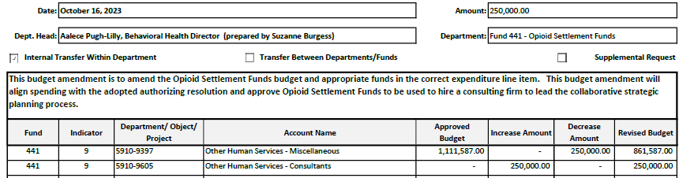

Resolution No. 2023-31

A RESOLUTION BY THE COUNTY OF CABARRUS
TO DIRECT THE EXPENDITURE OF OPIOID SETTLEMENT FUNDS

WHEREAS Cabarrus County has joined national settlement agreements with companies engaged in the manufacturing, distribution, and dispensing of opioids, including settlements with drug distributors Cardinal, McKesson, and AmerisourceBergen, and the drug maker Johnson & Johnson and its subsidiary Janssen Pharmaceuticals;

WHEREAS the allocation, use, and reporting of funds stemming from these national settlement agreements and certain bankruptcy resolutions (“Opioid Settlement Funds”) are governed by the Memorandum of Agreement Between the State of North Carolina and Local Governments on Proceeds Relating to the Settlement of Opioid Litigation (“MOA”);

WHEREAS Cabarrus County has received Opioid Settlement Funds pursuant to these national settlement agreements and deposited the Opioid Settlement Funds in a separate special revenue fund as required by section D of the MOA;

WHEREAS section E.6 of the MOA states:

E.6. Process for drawing from special revenue funds.

- Budget item or resolution required. Opioid Settlement Funds can be used for a purpose when the Governing Body includes in its budget or passes a separate resolution authorizing the expenditure of a stated amount of Opioid Settlement Funds for that purpose or those purposes during a specified period of time.

- Budget item or resolution details. The budget or resolution should (i) indicate that it is an authorization for expenditure of opioid settlement funds; (ii) state the specific strategy or strategies the county or municipality intends to fund pursuant to Option A or Option B, using the item letter and/or number in Exhibit A or Exhibit B to identify each funded strategy, and (iii) state the amount dedicated to each strategy for a stated period of time.

NOW, THEREFORE BE IT RESOLVED, in alignment with the NC MOA, Cabarrus County authorizes the expenditure of opioid settlement funds as follows:

- Strategy authorized
  - Name of strategy: Collaborative Strategic Planning
  - Strategy is included in Exhibit A (Exhibit A, Exhibit B)
  - Item letter and/or number in Exhibit A or Exhibit B to the MOA: 1
  - Amounted authorized for this strategy: $250,000.00
  - Period of time during which expenditure may take place:
Start date 10/17/2023 through End date 06/30/2024
  - Description of the program, project, or activity:
Contract with a consulting firm, identified through a competitive bidding process, to coordinate the Collaborative Strategic Planning Process for Cabarrus County; several activities (listed under Exhibit C) will be included in the process, including, but not limited to a) identifying goals, measures, and an evaluation plan; b) identifying key indicators; c) engaging diverse stakeholders; d) agreeing on shared vision; e) identifying and exploring root causes of the opioid epidemic; f) identifying gaps in existing efforts; and g) prioritizing strategies
  - Provider: Health Management Associates

The total dollar amount of Opioid Settlement Funds appropriated across the above named and authorized strategies is $ 250,000.00.

Adopted this the 16th day of October, 2023.

/s/ Stephen M. Morris__________________
Stephen M. Morris, Chair
Cabarrus County Board of Commissioners

ATTEST:

/s/ Lauren Linker_________________
Lauren Linker, Clerk to the Board

(F) REPORTS

(F-1) BOC - Receive Updates from Commission Members who Serve as Liaisons to
Municipalities or on Various Boards/Committees

Chairman Morris highlighted some information contained in the Crisis Support Quarterly report.

The allotted time during regular meetings to receive updates from commission members that serve as liaisons to local municipalities or that serve on various boards/committees, if needed. This opportunity allows the board members to learn more about what is going on with the boards each commissioner is individually involved with.

Commissioner Wortman, liaison for the town of Midland, reported the town of Midland had North Carolina Department of Transportation and Duke Energy at their town meeting in an effort to find a solution for a stretch of road where several accidents have occurred.

Vice Chairman Shue, liaison for the Water and Sewer Authority of Cabarrus County, reported all is on track for the reallocations.

Chairman Morris, liaison for the Transportation Advisory Board, announced the Transportation Department vacancies have been 100% filled.

(F-2) BOC - Request for Applications for County Boards/Committees

Information provided regarding vacant positions on the Cabarrus County Boards & Committees.

Vacant Positions on the Cabarrus County Boards & Committees are as follows:

- Adult Care Home Community Advisory Committee – 13 Vacant Positions
- Concord Planning and Zoning Commission (ETJ) – 1 Vacant Position
- Harrisburg Planning and Zoning Commission (ETJ) – 1 Vacant Position
- Home and Community Care Block Grant Committee – 1 Vacant Position
- Library Board of Trustees – 2 Vacant Positions

- Mental Health Advisory Board – 1 Vacant Position
- Nursing Home Community Advisory Committee – 11 Vacant Positions
- Planning and Zoning Commission – 1 Vacant Position
- Region F Aging Advisory Committee – 2 Vacant Positions
- Senior Centers Advisory Council – 1 Vacant Position
- Transportation Advisory Board – 6 Vacant Positions
- Youth Commission – 4 Vacant Positions

(F-3) Budget - Monthly Budget Amendment Report

The Board received the monthly budget amendment report for informational purposes. No action was required of the Board.

(F-4) Budget - Monthly Financial Update

The Board received the monthly financial update report for informational purposes. No action was required of the Board.

(F-5) County Manager - Monthly Building Activity Reports

The Board of Commissioners requested monthly reports of building and permit activities including information of plans under review. No action was required of the Board.

(F-6) DHS - Crisis Support Quarterly Report

The Board received the quarterly crisis assistance report for informational purposes. No action was required of the Board.

(F-6) EDC – September 2023 Monthly Summary Report

The Cabarrus Economic Development Corporation (EDC) provides monthly updates on the local economic and industry activities in the form of the included report. No action was required of the Board.

(G) GENERAL COMMENTS BY BOARD MEMBERS

Adit Kamdar, Youth Commission, announced they are working on community classes to share how to access fresh and organic foods.

(I) CLOSED SESSION

(I-1) Closed Session – Pending Litigation and Acquisition of Real Property

UPON MOTION of Vice Chairman Shue, seconded by Commissioner Wortman, and unanimously carried, the Board moved to go into closed session to discuss matters related to pending litigation and acquisition of real property as authorized by NCGS 143-318.11(a)(3) and (5).

UPON MOTION of Commissioner Wortman, seconded by Commissioner Furr and unanimously carried, the Board moved to come out of closed session.

(J) ADJOURN

UPON MOTION of Commissioner Furr, seconded by Commissioner Measmer and unanimously carried, the meeting adjourned at 8:31 p.m.

___________________________________
Lauren Linker, Clerk to the Board

